One Day Workshop on
Kitchen Garden and Soil Quality Assessment
Jointly Organised by IQAC, NSS and Department of Assamese, Nowgong Girls’ College, Nagaon
In Collaboration with Regional Agricultural Research Station, Shillongini, Nagaon.
Date: 09/01/2020
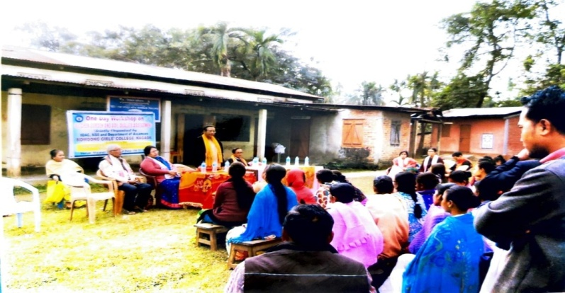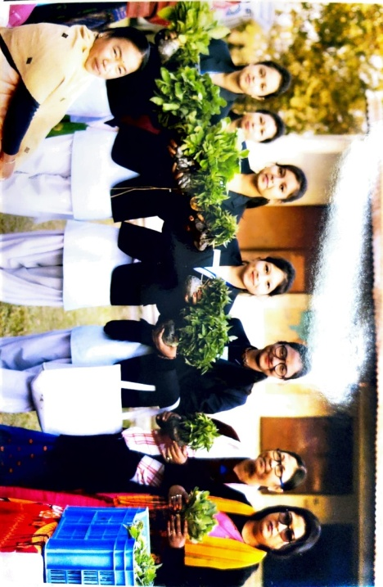
- Dr Amal Kumar Sarma and junior scientist Dr Nasima Rehman of Assam Agriculture University, Shilongni are joined as a resource persons.
- The purpose of the workshop is to train the female persons of the adopted village Itapara.
- Students of the department along with the NGCSU members.

