Free Coaching Class for Class IX & X
Organized by
Department of Assamese, Nowgong Girl’s College
In collaboration with
Bihubori Pragatishil Yuva Mancha, Dharamtul
Date: 1st Oct. to 31st December, 2021
Venue: Kothalguri LP School, Dharamtul
Coordinator: Dr Amiya Patar, HoD, Assamese
The programme was inaugurated by Dr Manju Laskar, senior most associate professor of the Department. The programme is organized for the economically weak students those who are in class IX and X. Three teachers are appointed to teach Mathematics, English and Science for the stipulated period. Remuneration of Rs. 2000/- per faculty is given.

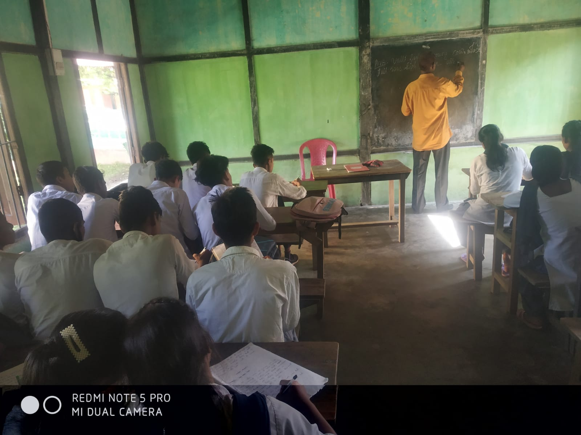
The following students were present in the programme:
- Nandita Dewri
- Ranjumoni Pator
- Babul Bordoloi
- Mintu Deka
- Moni Manta
- Ranjita Bordoloi
- Kiran Deka
- Prabin Deka
- Mamoni Pator
- Dipika Senapati
- Rupam Dewri
- Dilip Pator
- Manoj Manta

- Biswa Deka
- Rituraj Pator
- Matu Dewri
- Nabin Deka
- Karabi Pator
- Niharika Senapati
- Budhen Bordoloi
- Manikon Dekaraja
- Rita Pator
- Anikita Bordoloi

