Department of Assamese, Nowgong Girls’ College
Departmental Activities, 2025

- International Mother Tongue Day Observed
On 21st February, the International MotherTongue Day has been observed and the program was organized jointly by the Department of Assamese Nowgong Girls’ College, Nagaon, and Department of Assamese, Samaguri College, and IQAC, Samaguri College, at Samguri.
For this occasion, second Pulin Pator memorial lecture program has been organized on Galpakar Mahim Bora, a reknown Assamese short story writer of Assamese literature. Dr Somnath Bora, Associate Professor, Samaguri College and short story writer, Dr Kamal Saikia, one of the well known critics and vice principal of B.K.B. College, Dr Biswajit Das of Nowgong Girls’ College delivered lectures.
The PG and UG students of both colleges were present in the occasion.

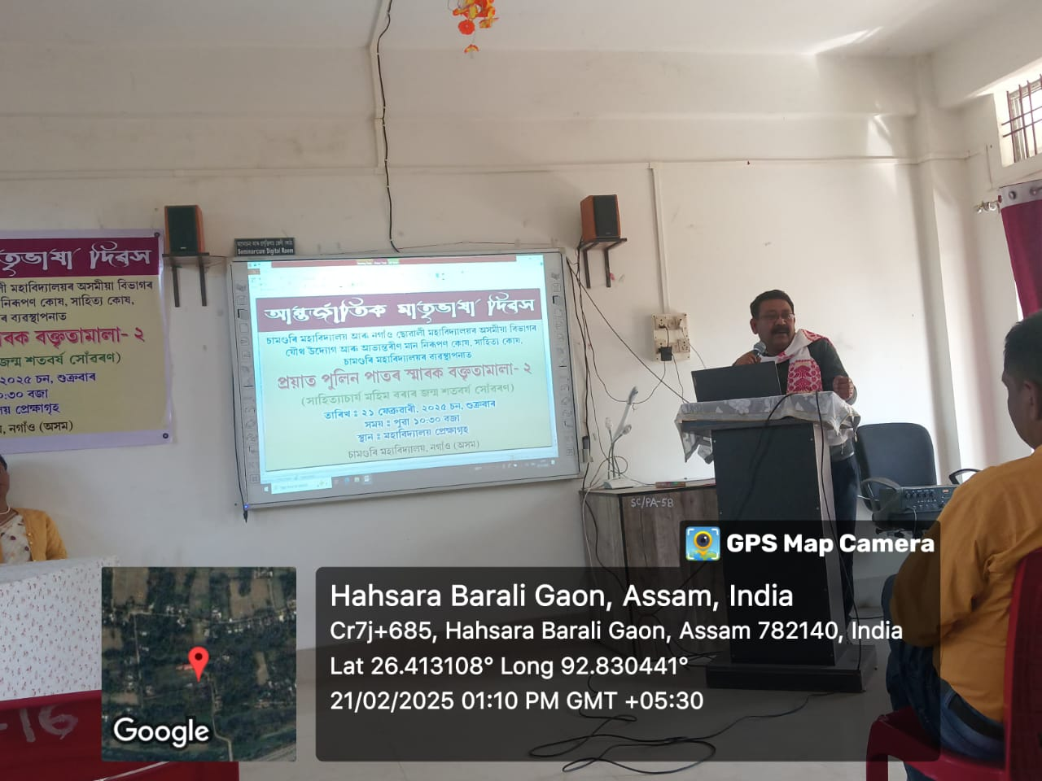

- Parent Teacher Meet
On 18/03/2025, Department of Assamese, Nowgong Girls’ College organized a PTM at The conference hall of the College. The meeting was attended by all the Teachers of the Department and the guardians of UG second, fourth and sixth Semester as well as PG second and fourth Semester students. In this meeting the teachers discussed with the parents about various problems faced by the students, the issue of NEP as well as their educational aspects. The teachers also briefed the measures to be taken for the upliftment and day to day development of the students.

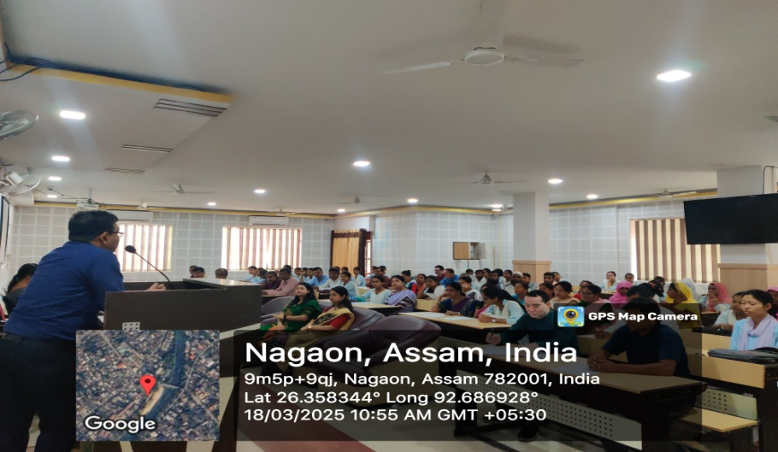
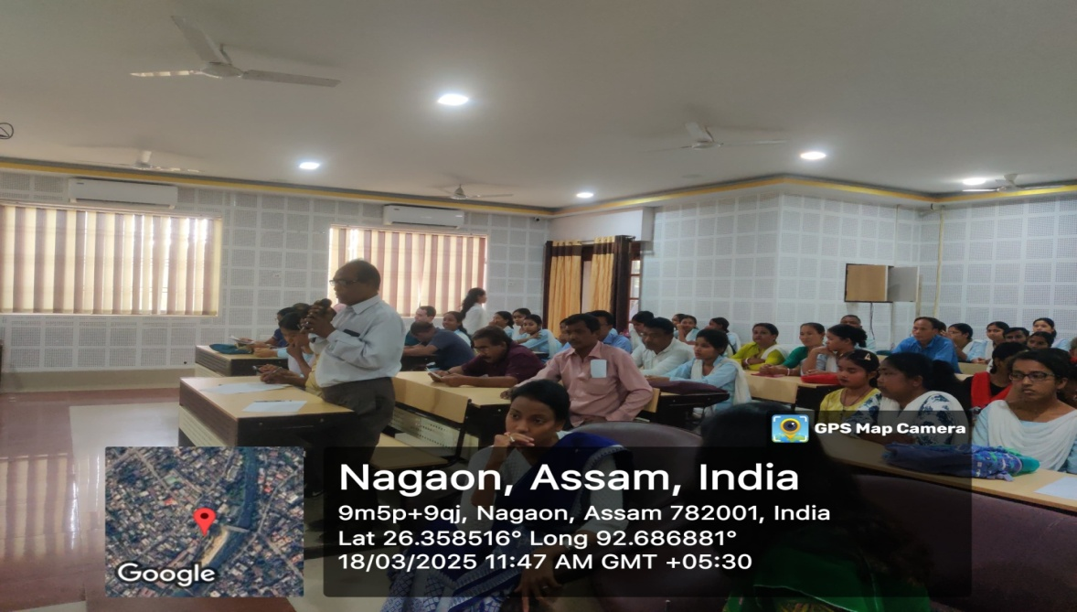
- Field Trip for UG and PG Students

On 05/04/2025, the students of UG sixth Semester and PG fourth Semester of the Department with all the teachers of the Department went for a field trip to Mayong, Marigaon District with an aim to visit the Rock Inscription of Burha Mayong. We hope the students learned something new and the field study benefited them for their theory paper Textual Criticism.

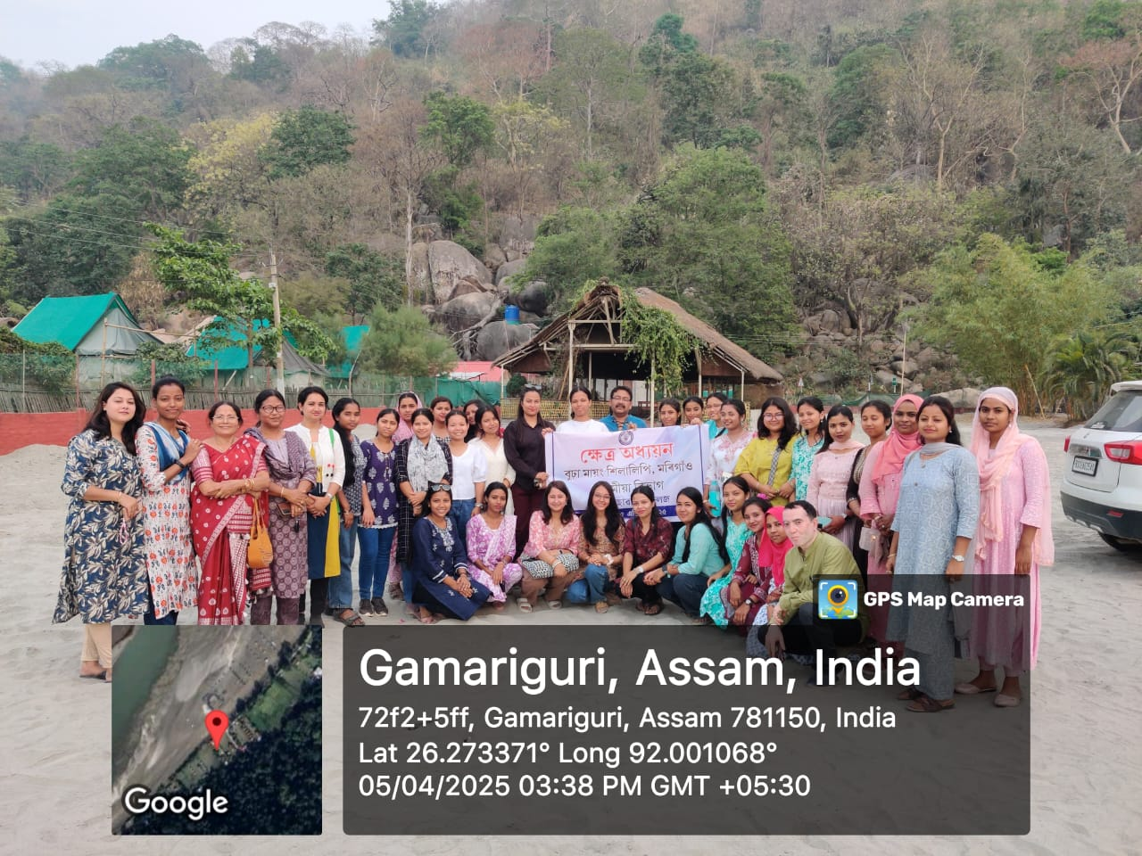
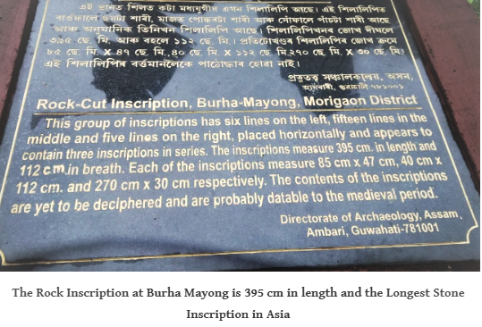

- A Visit to Archaeological Place by the Teachers

On 14/05/2025, all the teachers of the Department went to visit an archaeological place near Kampur of Nagaon District. In the month of February, 2025, some rock sculptures as well gold ornaments arround seven k.g was found in a hill-like area in the middle of a paddy field in Barchung area of Kampur in Nagaon District. Some black stone statues of various shapes and vague inscriptions carved on stones of various sizes have been seen.
The archaeological department, which has already taken charge of the excavation operation, will start excavations soon, locals said, adding that more sculptures have been found at the site.

