Parent-Teacher Meeting
Department of Sanskrit
Nowgong girls’ college
On 18th March 2025, at 11:00 AM, the Sanskrit Department of Nowgong Girls' College organized a Parent-Teacher Meeting to discuss important matters regarding the students’ academic progress and overall well-being. The meeting aimed to strengthen the collaboration between teachers and parents in supporting the students’ learning journey. Key topics included the performance of students in Sanskrit, upcoming exams, and strategies to enhance their engagement with the subject. Teachers highlighted areas where students excelled and areas requiring improvement. The meeting was a productive session for mutual growth and progress.
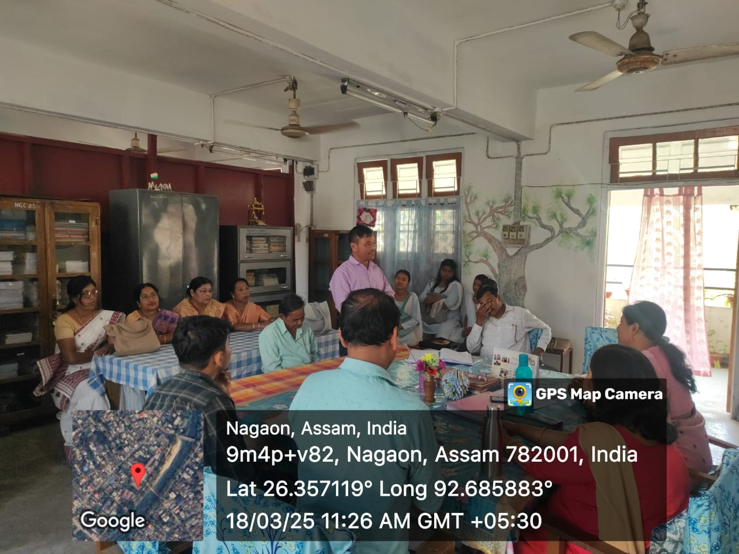

Priti Sabha Organized by the Department of Sanskrit

The Department of Sanskrit organized a Priti Sabha for the B.A. 6th Semester students. The meeting was held in the Department premises with the gracious presence of the former Vice Principal and HOD Dr. Mira Baruah. All faculty members of the Department of Sanskrit, along with the students of B.A. 6th Semester, attended the meeting. The gathering was marked by a warm and cordial atmosphere, reflecting the spirit of academic camaraderie and farewell. Dr. Mira Baruah addressed the students with inspiring words, encouraging them to pursue knowledge with dedication and to uphold the values of Sanskrit learning. Faculty members also shared their experiences and extended their best wishes to the outgoing students. The event concluded with expressions of gratitude and good wishes from the students, making the Priti Sabha a memorable occasion for all present.

