Report on the Observance of International Mother Tongue Day

Organized by the Department of Assamese, Nowgong Girls’ College, Department of Assamese, Samaguri College, and IQAC, Samaguri College

Event Overview
On February 21, 2025, International Mother Tongue Day was observed with a collaborative program organized by the Department of Assamese, Nowgong Girls’ College, Nagaon, the Department of Assamese, Samaguri College, and the Internal Quality Assurance Cell (IQAC), Samaguri College, held at Samaguri. The event aimed to celebrate the significance of linguistic diversity and promote the preservation of the Assamese language as a vital component of cultural heritage.

Second Pulin Pator Memorial Lecture
The highlight of the occasion was the Second Pulin Pator Memorial Lecture, dedicated to the life and works of the renowned Assamese short story writer, Mahim Bora. The lecture program featured distinguished speakers who provided insightful perspectives on Bora’s contributions to Assamese literature:
- Dr. Somnath Bora, Associate Professor at Samaguri College and an acclaimed short story writer, discussed the narrative techniques and cultural significance of Mahim Bora’s stories, emphasizing their enduring relevance in Assamese literature.
- Dr. Kamal Saikia, Vice Principal of B.K.B. College and a well-known literary critic, analyzed the thematic depth and stylistic nuances of Bora’s works, highlighting their impact on Assamese short story traditions.
- Dr. Biswajit Das, faculty member of Nowgong Girls’ College, explored the socio-cultural contexts in Mahim Bora’s writings, underscoring their role in reflecting Assamese identity and values.
The lectures collectively celebrated Mahim Bora’s legacy while fostering a deeper appreciation for the Assamese language and its literary heritage among the attendees.

Participation

The event saw active participation from postgraduate and undergraduate students of both Nowgong Girls’ College and Samaguri College. Faculty members from the organizing departments also attended, contributing to the program’s success through their guidance and engagement. The presence of students from diverse academic levels highlighted the event’s role in inspiring the younger generation to value their mother tongue and its literary traditions.

Significance
The observance of International Mother Tongue Day underscored the importance of preserving linguistic diversity as a cornerstone of cultural identity. By dedicating the Second Pulin Pator Memorial Lecture to Mahim Bora, the program paid tribute to one of Assam’s literary stalwarts while reinforcing the role of the Assamese language in shaping regional identity. The collaborative effort between Nowgong Girls’ College and Samaguri College, supported by IQAC, exemplified the commitment of academic institutions to promote linguistic and cultural heritage.

Conclusion
The International Mother Tongue Day celebration on February 21, 2025, organized jointly by the Department of Assamese, Nowgong Girls’ College, the Department of Assamese, Samaguri College, and IQAC, Samaguri College, was a resounding success. The Second Pulin Pator Memorial Lecture, with its focus on Mahim Bora’s contributions, provided a platform for intellectual discourse and cultural reflection. The enthusiastic participation of students and faculty underscored the event’s impact in fostering pride in the Assamese language and its literary legacy, setting a precedent for future initiatives to promote linguistic diversity.

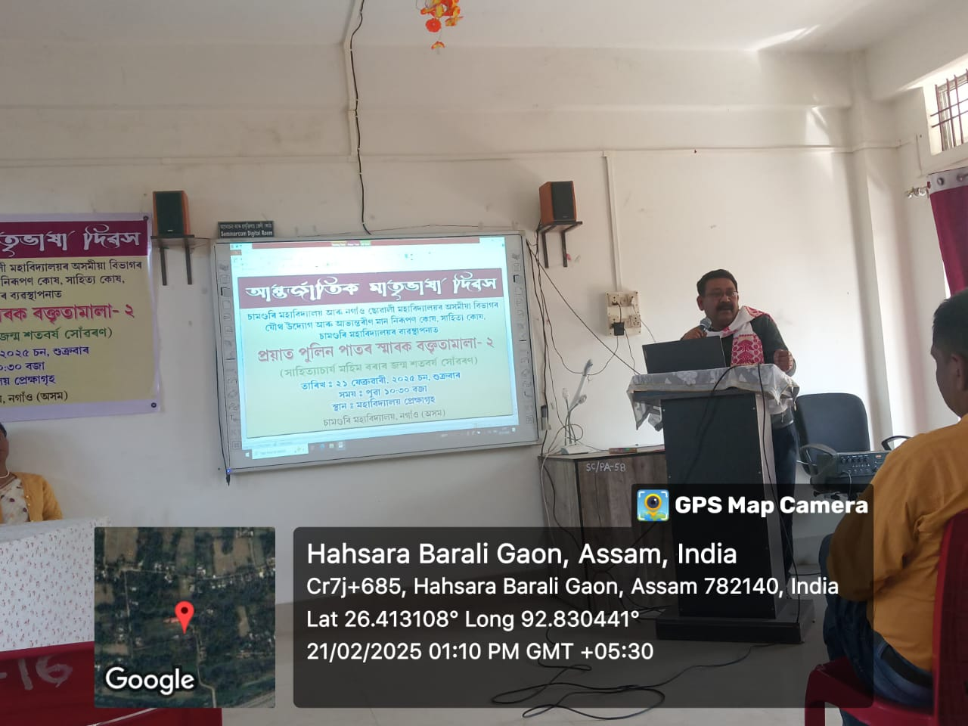

Report on Jangal Balahu Garh: Significance, Challenges, and Plantation Drive

Organized by NSS in Collaboration with IQAC and Assamese Department, Nowgong Girls’ College

Event Overview
On [date to be specified], the National Service Scheme (NSS) unit of Nowgong Girls’ College, in collaboration with the Internal Quality Assurance Cell (IQAC) and the Assamese Department, organized a significant program at Jangal Balahu Garh, Nagaon, Assam. The event focused on highlighting the historical and cultural importance of Jangal Balahu Garh, addressing the challenges in its preservation, and conducting a plantation drive to promote environmental sustainability. The program saw active participation from teachers and students of the Assamese Department, reflecting their commitment to preserving cultural heritage and fostering ecological responsibility.

Keynote Lecture by Dr. Indrajit Bezbaruah
The event featured an insightful lecture delivered by Dr. Indrajit Bezbaruah, Principal of Samaguri College. Dr. Bezbaruah elaborated on the historical and cultural significance of Jangal Balahu Garh, an ancient earthwork fort attributed to the Ahom dynasty. He emphasized its role as a testament to Assam’s rich historical legacy, highlighting its strategic importance during the Ahom period as a defensive structure. The fort, located in Nagaon district, stands as a symbol of the region’s architectural ingenuity and military history.
Dr. Bezbaruah also addressed the challenges facing the preservation of Jangal Balahu Garh, including natural degradation, encroachment, and lack of awareness about its historical value. He underscored the need for community-driven efforts to protect such heritage sites from further deterioration, urging students to advocate for their conservation. Additionally, he linked the preservation of historical monuments to environmental sustainability, noting that a healthy ecosystem around such sites can mitigate erosion and enhance their longevity.

Plantation Drive
Following the lecture, a plantation drive was conducted at Jangal Balahu Garh, aligning with the event’s dual focus on cultural preservation and environmental stewardship. Organized by the NSS unit in collaboration with the Assamese Department and IQAC, the drive involved planting native tree saplings around the fort’s vicinity. This initiative aimed to combat soil erosion, enhance the aesthetic appeal of the site, and promote environmental sustainability. The plantation effort symbolized the college’s commitment to integrating cultural heritage preservation with ecological conservation.

Participation
The program witnessed enthusiastic participation from teachers and students of the Assamese Department. Faculty members provided guidance, ensuring seamless coordination between the lecture and the plantation drive. Students actively engaged in planting saplings and participated in discussions about the fort’s significance, demonstrating their dedication to both cultural and environmental causes. Their involvement highlighted the spirit of community service and civic responsibility promoted by the NSS and IQAC.

Significance of Jangal Balahu Garh
Jangal Balahu Garh is a significant historical monument, reflecting the architectural and strategic prowess of the Ahom dynasty. The fort’s earthwork structure and its historical role in regional defense make it an invaluable part of Assam’s cultural heritage. However, challenges such as soil erosion, vegetation overgrowth, and limited conservation efforts threaten its preservation. The event aimed to raise awareness about these issues, encouraging collective action to safeguard the site for future generations.

Challenges in Preservation
The lecture and discussions highlighted several challenges in preserving Jangal Balahu Garh:
- Environmental Degradation: Natural factors like soil erosion and heavy rainfall contribute to the deterioration of the fort’s structure.
- Encroachment and Urbanization: The expansion of human settlements poses a threat to the site’s integrity.
- Lack of Awareness: Limited public knowledge about the fort’s historical significance hinders community-driven conservation efforts.
- Insufficient Funding: Inadequate resources for maintenance and restoration limit the scope of preservation initiatives.
Dr. Bezbaruah emphasized that addressing these challenges requires collaborative efforts from academic institutions, local communities, and government bodies.

Outcomes
The program successfully educated participants about the historical and cultural importance of Jangal Balahu Garh while addressing the urgent need for its preservation. The plantation drive contributed to environmental conservation by promoting afforestation around the site, which helps mitigate erosion and enhances the fort’s surroundings. The active involvement of students and faculty fostered a sense of responsibility toward preserving Assam’s heritage and environment, aligning with the broader goals of the NSS and IQAC.

Conclusion
The event at Jangal Balahu Garh, organized by the NSS unit in collaboration with the IQAC and Assamese Department of Nowgong Girls’ College, was a resounding success. Dr. Indrajit Bezbaruah’s lecture provided a comprehensive understanding of the fort’s historical significance and the challenges in its preservation, while the plantation drive reinforced the importance of environmental stewardship. The enthusiastic participation of teachers and students underscored the college’s commitment to fostering cultural and ecological awareness. This initiative serves as a model for future programs aimed at preserving Assam’s historical monuments while promoting sustainable environmental practices.
